Progress in Demonstration Models Component
Canada-Russia Disability Program, Mental Health Stream
Mid-Term Summary
May 31, 2005

Stavropol Region

Activities have been two-fold: 1) promoting inter-sectorial multidisciplinary approaches to trauma response (TR), and 2) promoting the development of community-based mental health rehabilitation (CMHR).

Trauma response capacity development
- A four-event multidisciplinary cross-sector training program has been completed (two Canada-led and two Russia-led events), with a total number of participants over 250. Included were professionals from sectors such as police, education, social protection, military, mental health and others.
- It is planned that an inter-sectorial working group will be established to coordinate services to persons who experienced psychic trauma.
- A Psycho-Social Support Clinic (“Cabinet”) established at the Mental Health Service Dispensary for assistance in crisis and trauma situations (out-patient, community-oriented, multi-disciplinary team model) provides crisis phone line service, counseling, referral, and case management.
- Professional trauma-response expertise has been extended to providing outreach emergency services to victims and survivors of emergency events (e.g. Beslan tragedy, Kislovodsk train explosion).
- Methodological recommendations are being developed for federal government adoption, based on regional experience in trauma response.

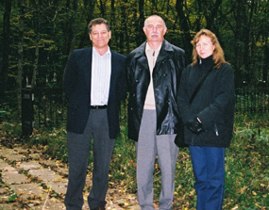

Paul Gronnerud (Calgary), Dr. Igor Bylim (Stavropol)
and Dr. Natalia Semenova (Moscow) in Stavropol,
Trauma Response Training event, October 2003

Enhancing community-oriented approaches
- Rehabilitation unit was established in the hospital edge-of-town facility, led by a COL graduate who was given responsibility for reforming the unit. He re-oriented the focus from long-term treatment of persons with chronic psychiatric illness towards facilitating rehabilitation, with the major objective of discharge preparation. Residents are provided with community living skill training to prevent hospital re-admission due to community living barriers. The reform included hiring and training new personnel, involving student volunteers, re-organizing unit structure and functions, and on-going staff education. Training was also provided to staff members of other mental health service facilities.
- The Dispensary has developed a psycho-social Day Program for small groups of patient and family members. Psycho-educational multi-family groups have been developed for people with psychiatric illness and their family members (inpatient/outpatient groups).
- A number of programs adopting a bio-psycho-social approach are in early development stages. These include:
  - Housing program: plans are in place to develop a supported living dormitory at the site of a former monastery, once the population reduces and space is available.
  - A First Episode Clinic: day treatment option for community-based support is to be implemented, as well as male in-patient unit (currently the program operates within a female in-patient unit).
  - Two “sanatorium” rehabilitation units have been established for people with non-psychotic mental health disorders, including posttraumatic stress disorder.
- Labour market for patients: a data-base on employment options will be developed by different employers in the area, which will be supported by a social worker.
- Active discussion underway between MH and Labor and Social Protection Ministry to provide psycho-social programming support in Social Service Centres.
- The regional Branch of New Choices is being chartered and formally registered with support of professionals.
- Publication titled “Social work in psychiatry: establishment, development, experience” (professional manual) authored by I. Bylim, T. Maslova, M. Porubaeva, edited by E. Shiyanov, has been published (2004).

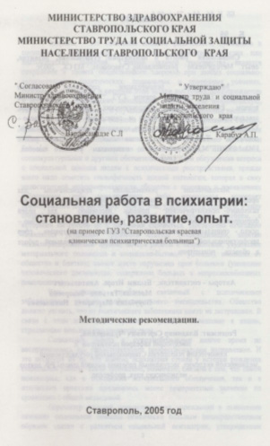

Front page of the Methodological Recommendations (Policy Manual) on Social Work in Psychiatry, issued by Stavropol regional Ministry of Health, 2005

